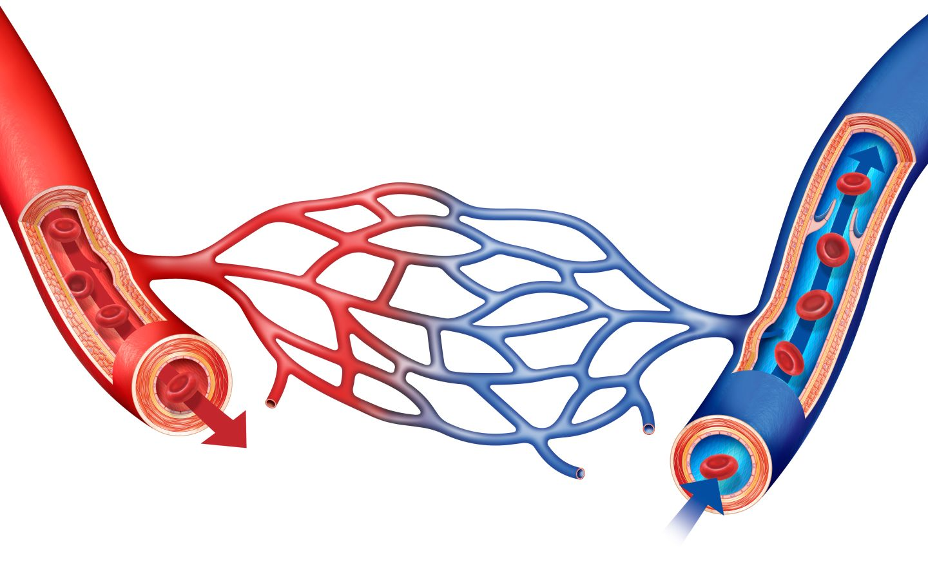
Blood Vessel Comparison

 | ARTERIES | VEINS | CAPILLARIES
Direction of Blood Flow

Size

Wall Size and Structure

Pressure

Valves Yes/No

Special/Interesting Characteristics

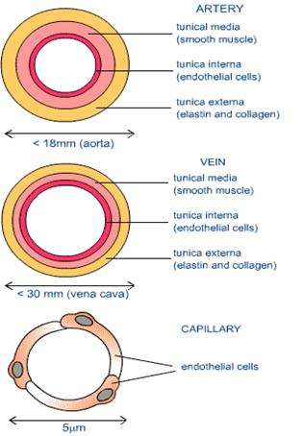
Diagram

